Department of Software Engineering
Mehran University of Engineering and Technology, Jamshoro

Course: SWE324 - Data Warehousing and Data Mining
Instructor | Rabeea Jaffari | Practical/Lab No. | 04
Date |  | CLOs | CLO-4: P3 & P4
Signature |  | Assessment Score | 1 Mark

Topic | To familiar with OLTP system reporting
Objectives | To learn report generation in OLTP systems

Lab Discussion: Theoretical concepts and Procedural steps

Generate an OLTP system report which displays the following results:

Total sales in a month (Use only order table).
Profit/loss in a month (Use product (to account for purchasing costs), expenditure as well as order tables).
Highest selling product of the month (By highest sold quantity)
Lowest selling product of the month (By lowest sold quantity)

Hint: Create a report table to hold all the above results from queries after they are executed in the stored procedure and then create a stored procedure in the similar manner as shown above.

TASK:
Customer:
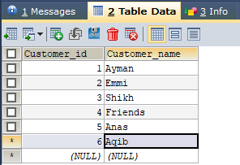

Order:
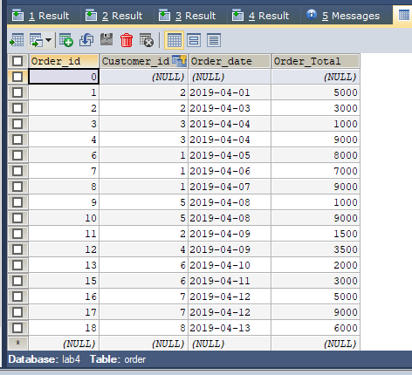
Order_details:
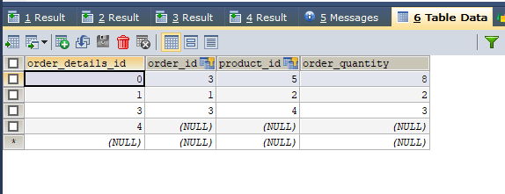

Expenditure:
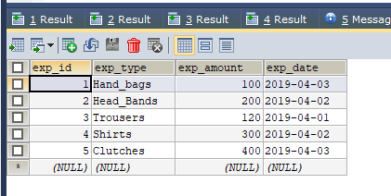
Product:
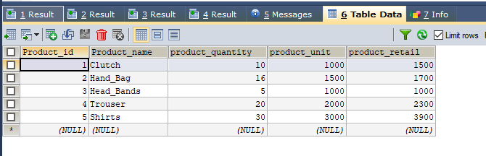

Sales_Report

DELIMITER $$

CREATE
/*[DEFINER = { user | CURRENT_USER }]*/
PROCEDURE `lab4`.`Sales_report`()
/*LANGUAGE SQL
| [NOT] DETERMINISTIC
| { CONTAINS SQL | NO SQL | READS SQL DATA | MODIFIES SQL DATA }
| SQL SECURITY { DEFINER | INVOKER }
| COMMENT 'string'*/
BEGIN
SELECT @SALES:=SUM(Order_Total) FROM `lab4`.`order` WHERE Order_date LIKE '2019-04-%';
INSERT INTO report(TYPE,amount) VALUES ('total_sales',@SALES);
SELECT @Profit:= SUM(product.Product_retail)- (SUM(expenditure.exp_amount)+SUM(product.product_Unit)) AS profit
FROM `lab4`.`Product` INNER JOIN `lab4`.`expenditure` ON
Product.Product_id= expenditure.exp_id;
INSERT INTO report(TYPE,amount) VALUES ('profit/loss',@Profit);
SELECT @highest_selling_product:= product.`Product_name` AS highest FROM `LAB4`.`product` INNER JOIN `LAB4`.`order_details` ON
product.product_id=(SELECT Product_id FROM order_details HAVING Order_quantity=MAX(order_quantity));
INSERT INTO report(TYPE ,amount) VALUES ('highest', @highest_selling_product);
SELECT DISTINCT @lowest_selling_product:=product.`Product_name` AS lowest FROM `LAB4`.`product` INNER JOIN `LAB4`.`order_details` ON
product.product_id=(SELECT Product_id FROM order_details WHERE Order_quantity=(SELECT MIN(order_quantity) FROM order_details));
INSERT INTO report(TYPE ,amount) VALUES ('lowest', @lowest_selling_product);
END$$

DELIMITER ;
